**Code Reusability**

* If we use the same kind of activity for different projects like login to the website, get customer details, connect to the terminal application, App navigation, Initialization etc. we should save these files into the centralized folders.

**Where to store the Reusable components:**

* These type of reusable components are store under the Library Folder, where the UiPath studio has been installed.
* “C:\Program Files (x86)\UiPath Studio\Library” in this path we have two folders, Create one more folder for reusable components.

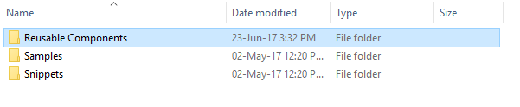

* Copy and paste the .xaml file which most often used for the project. Here I copy the Login.xaml (for example) file which I most often used.



* 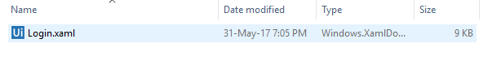Now we can able to see the folder which we created earlier in UiPath Studio under library Pane.

Note: Restart the UiPath Studio after Create the Folder.

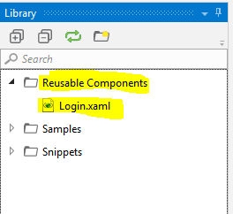

* Drag and Drop the Login.xaml wherever we need. test